4001CEM Software Design

SQL and Database Connectivity
In this lab, the activities have been designed to assist you in understanding Structured Query Language (SQL) for relational databases, building a database using XAMPP, which stands for Cross-Platform (X), Apache (A), MariaDB (M), PHP (P) and Perl (P) and connect the database to a Python program through examples and practical exercises. These lab activities will not be assessed. Please check your work with the session tutors if you require further help and support.

- Activity: XAMPP

  - Introduction to XAMPP

This section introduces the building of a relational database using the XAMPP tool. XAMPP is an open source cross-platform web server solution package for developers to create a local web server for testing and deployment purposes.

Example: In this section, the XAMPP tool will be used to build a simple database which contains a table, called Employee, as below.

- To find XAMPP, search Apps Anywhere and XAMPP on University computer and click on Launch to start the tool as follows:

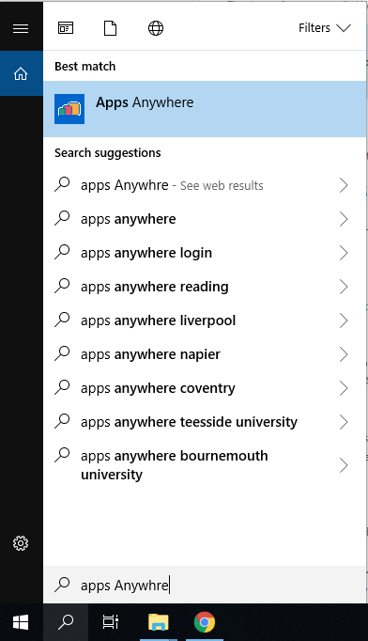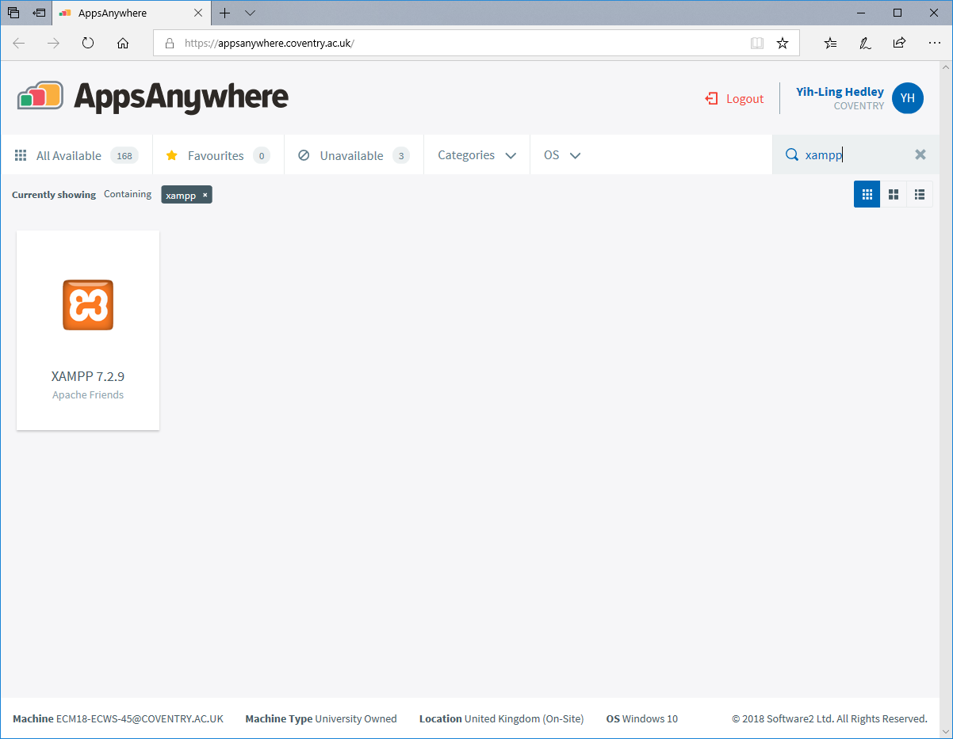

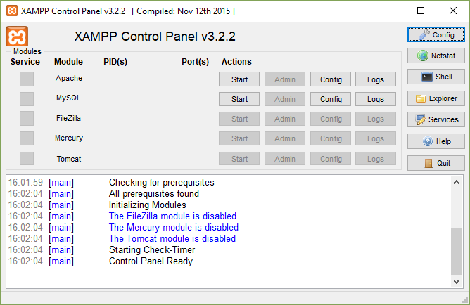
Start XAMPP Control Panel and click Create start the ERD tool.

Click Start button for Apache and MySQL

Apache and MySQL are starting as shown here.

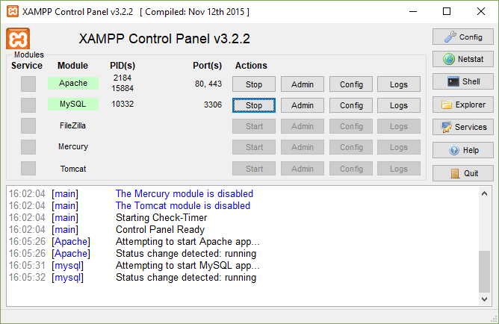

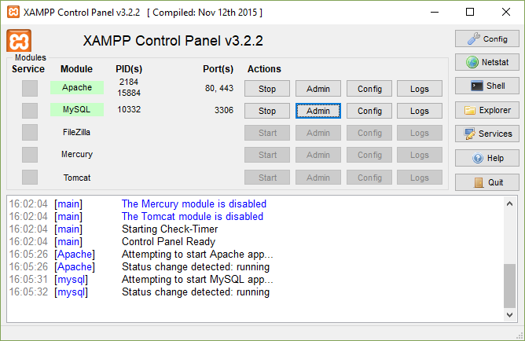
Click the Admin button for MySQL

The PhpMyAdmin interface is launched in the browser as below.

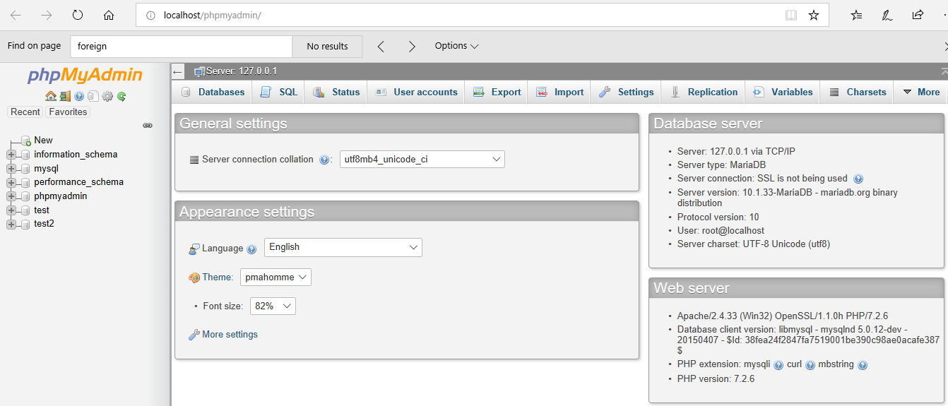

Click the Database button to get the access the database.

Click New.

Enter Example and click Create to create a new database.

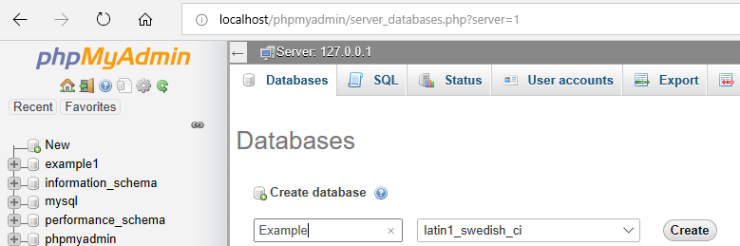

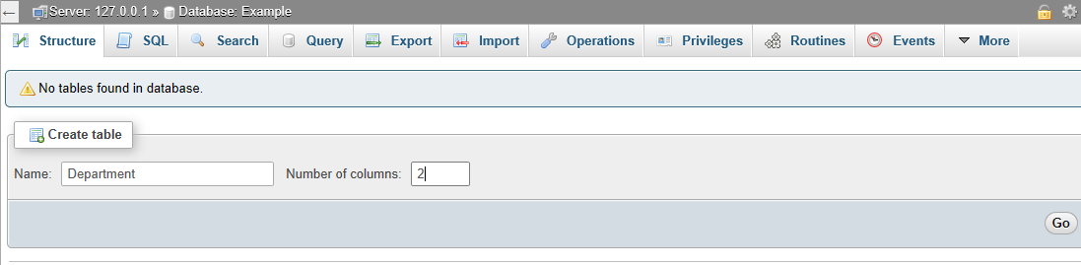

Enter Department in the Name field;

Enter 2 in the Number of columns field;

Click the Go button to create the table.

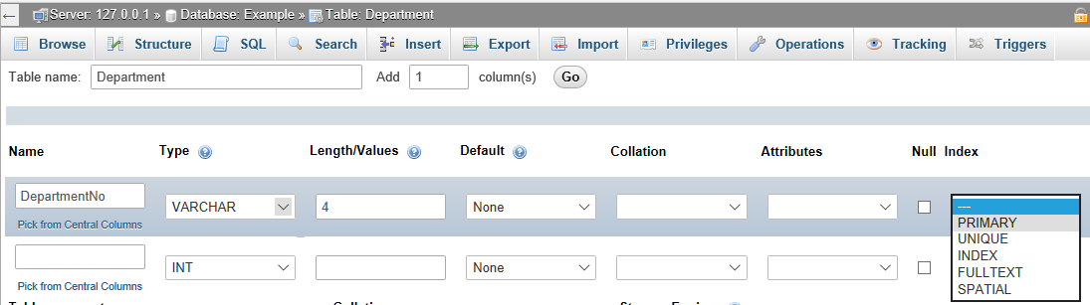

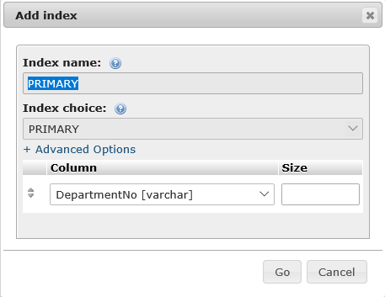
Enter the details as shown for the table.

Select Primary from the field here;

Click Go to complete.

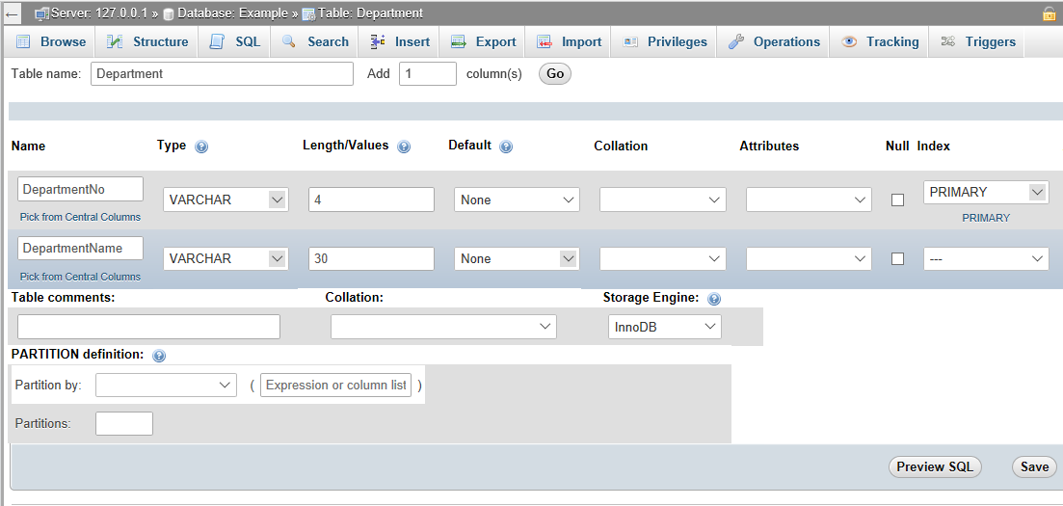
To add a new column, enter DepartmentName, select VARCHAR and enter 30 for the Name column;

Click Save.

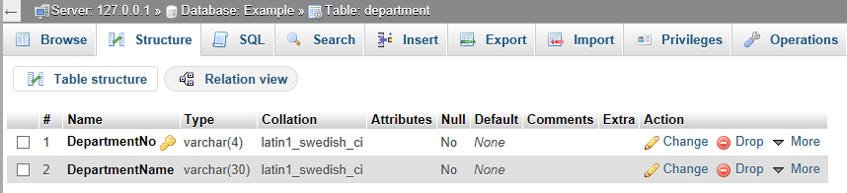

The table is created as shown here.

Go to Insert tab.

Enter the data, L004 and IT, to the fields here;

.

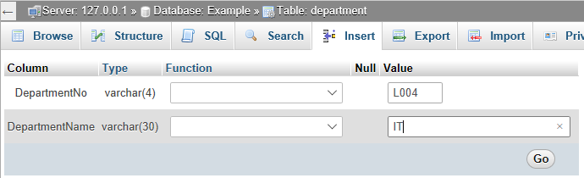

Click Go to create a new row of record.

The record is inserted with SQL statements as shown below.

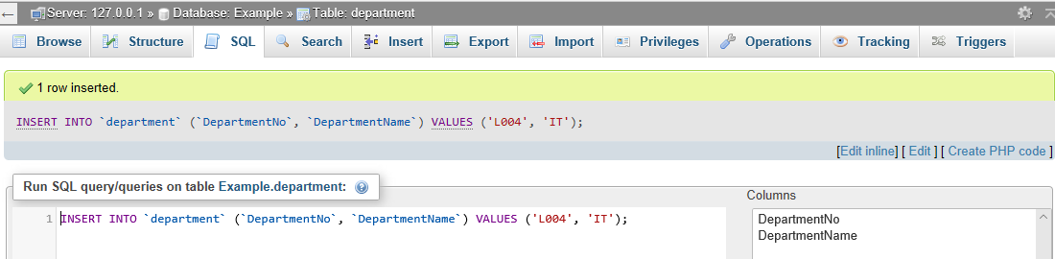

  - Activity

You are required to complete the following exercises in XAMPP to insert data into the database and perform a simple standalone query into the database.

Exercise 1: to add a new record into the Department table, with the following data:
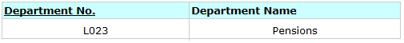

Note: once you have entered the above data, click on the Browse tab and you should see the two records entered.

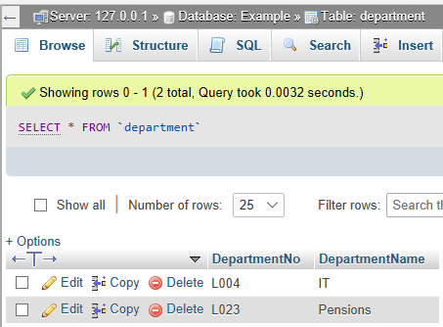

Exercise 2: to find out the list of departments using SQL statements.
Note: Click Server. 127.0.01 link to see the Databases tab. Go to the Databases tab and make sure you click example before next activity.

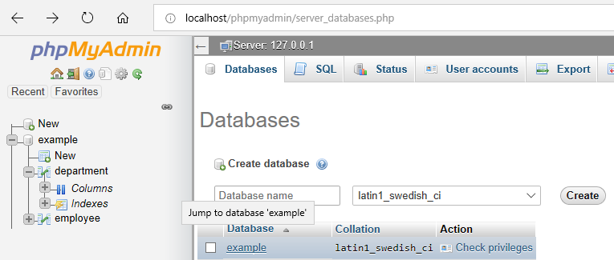

- Activity: SQL and MySQL Database

  - Python Program and MySQL Database Connectivity

In this section, you will be given an example of a Python program which is connected to a MySQL database via a mysql connector driver program.

Firstly, go to Apps Anywhere and search for PyCharm. Click on PyCharm Community edition and Launch the application.

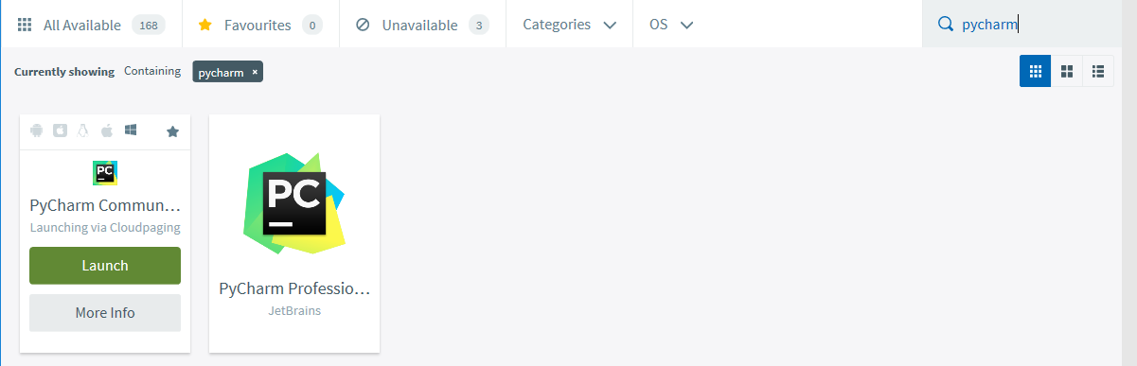

The following shows the steps to create a new project and a Python file in PyCharm.

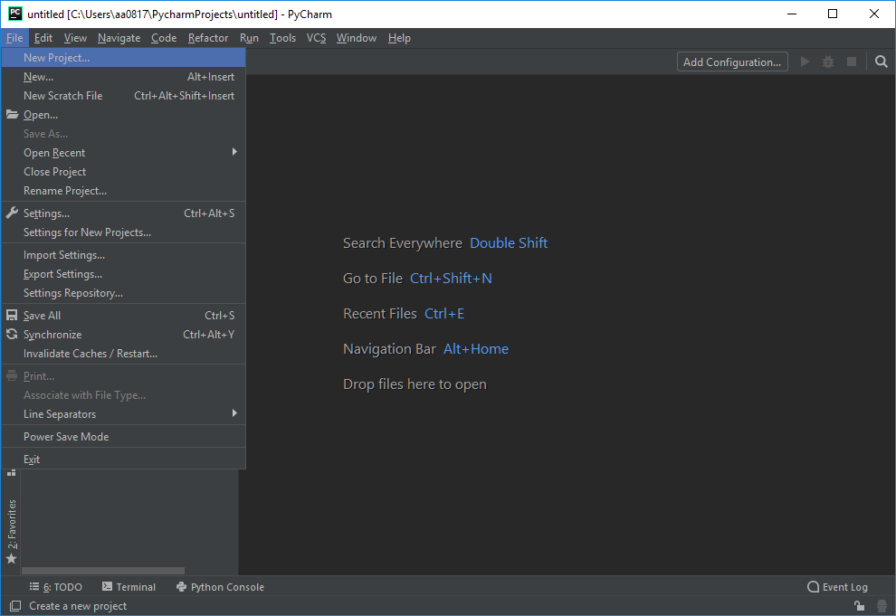
Go to File, click New Project

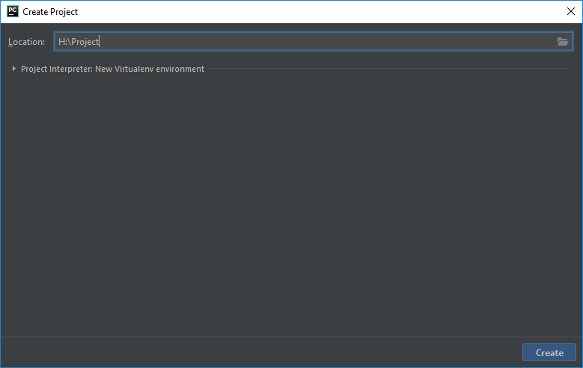
In the Location field, enter H: \Project (your Home drive if you are working on the University network and the folder, named Project)

Click Create to create a new project.

Click to open the list.

Click Existing interpreter

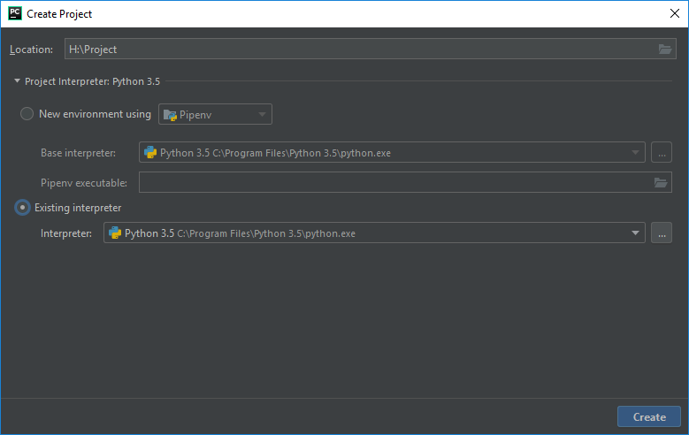

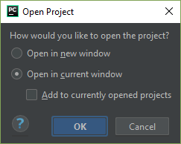
Click OK to open the window.

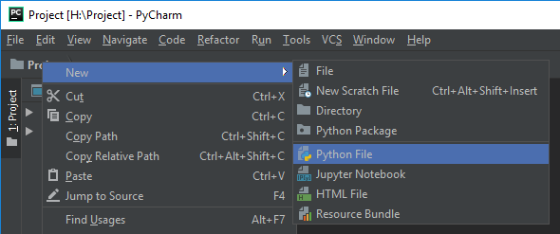
Right click on Project folder, New and click Python File

Give the SQLExample1 in the Name field

Click OK.

The SQLExample1.py window is shown as below.

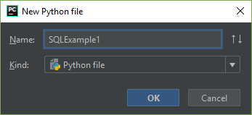

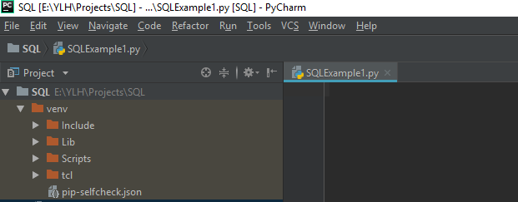
Example 1: The following Python script will connect to the MySQL Example. Enter the code below in the PyCharm IDE.

Notes: Please see details for MySQL Connector/Python API Reference at: https://dev.mysql.com/doc/connector-python/en/connector-python-reference.html

import mysql.connector
from mysql.connector import Error
def connect():
""" Connect to MySQL database """
try:
conn = mysql.connector.connect(host='localhost',
database='example',
user='root',
password='')
if conn.is_connected():
print('Connected to MySQL database')
except Error as e:
print(e)
finally:
conn.close()
if __name__ == '__main__':
connect()
Copy the code shown here and paste it into the SQLExample1.py window as shown below.

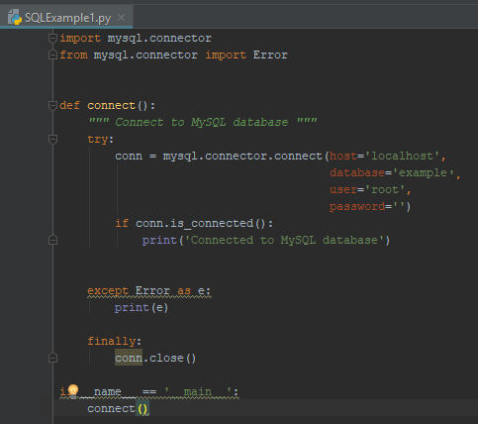
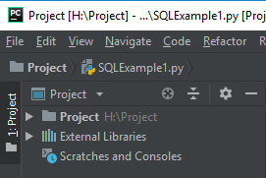

Click  to see the drop down list, with SQLExample1.

Right click on Run ‘SQLExample1’ to run the python script.

The result is shown below.
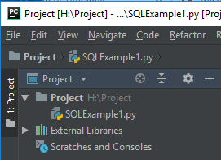

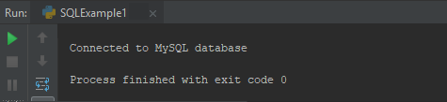
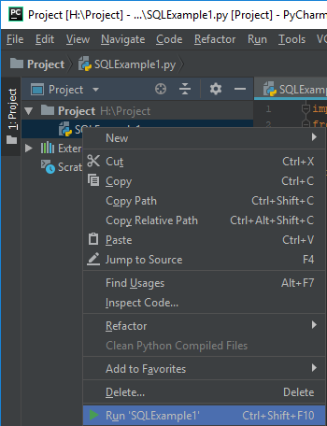

  - Embedded SQL Queries

2.2.1 SQL Statement: Select

This section introduces the SQL Select statements to view the records of a database table.

Example 2: The following Python script views all records of the Department table in the example database.
Notes: please see the details for the MySQLCursor Class, https://dev.mysql.com/doc/connector-python/en/connector-python-api-mysqlcursor.html

import mysql.connector
from mysql.connector import MySQLConnection, Error
def connect():
""" Connect to MySQL database """
try:
conn = mysql.connector.connect(host='localhost',
database='example',
user='root',
password='')
if conn.is_connected():
print('Connected to MySQL database')
except Error as e:
print(e)
return conn
def view_all(conn):
try:
cursor = conn.cursor()
cursor.execute("SELECT * FROM department")
rows = cursor.fetchall()
print('Total Record(s):', cursor.rowcount)
for row in rows:
print(row)
except Error as e:
print(e)
finally:
cursor.close()
conn.close()
if __name__ == '__main__':
conn = connect()
view_all(conn)
Create a Python file, named SQLExample2.py. Copy the code here and paste it into SQLExample2.py.

(mysql.connector module is used to connect to the example database.

You also need to import MySQLConnection)

The SQL SELECT statement (embedded in Python) retrieves all the records of the Department table.

Run the program, the results are shown as below:
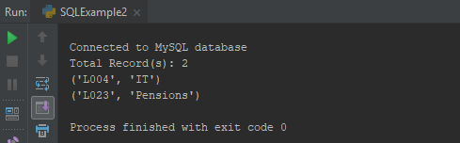

Exercise: Add your comments to the above Python program to ensure that you understand the code.
2.2.2 SQL Statement: Insert

This section introduces the SQL insert statements to insert records into a database table.

Example 3: The following Python script will insert a new record below into the Department table in the Example database.

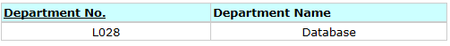

Create a Python file, named SQLExample3.py. Copy the code below and paste it into SQLExample3.py.

import mysql.connector
from mysql.connector import MySQLConnection, Error
def connect():
""" Connect to MySQL database """
try:
conn = mysql.connector.connect(host='localhost',
database='example',
user='root',
password='')
if conn.is_connected():
print('Connected to MySQL database')
except Error as e:
print(e)
return conn
def insert(conn, num, name):
query = "INSERT INTO Department(DepartmentNo,DepartmentName) " \
"VALUES(%s,%s)"
args = (num, name)
try:
cursor = conn.cursor()
cursor.execute(query, args)
print('Number of records inserted: ', cursor.rowcount)
conn.commit()
except Error as error:
print(error)
def view_all(conn):
try:
cursor = conn.cursor()
cursor.execute("SELECT * FROM department")
rows = cursor.fetchall()
print('Total Record(s):', cursor.rowcount)
for row in rows:
print(row)
except Error as e:
print(e)
finally:
cursor.close()
conn.close()
if __name__ == '__main__':
conn = connect()
insert(conn, 'L028', 'Database')
view_all(conn)

Run the program, the results are shown below.

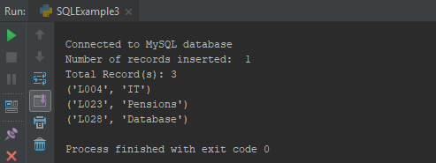

Refresh the phpMyAdmin interface, the Department table has a new record inserted.

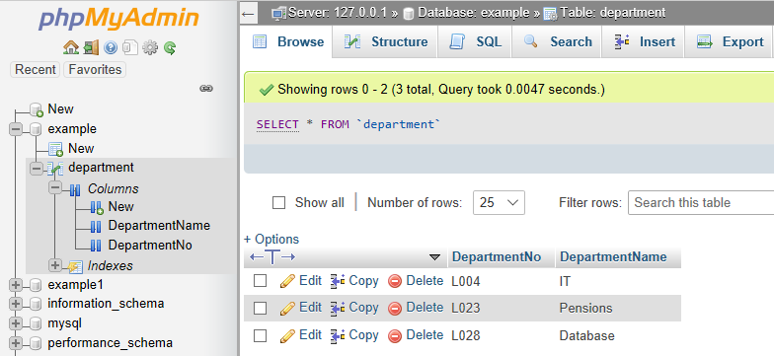

Exercise: Add your comments to the above Python program to ensure that you understand the code. Add the following record to the Department table:

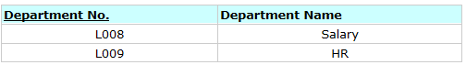

2.2.3 SQL Statement: Update

This section introduces the SQL update statements to update records of a database table.

Example 4: The following Python script will update the name of department to Recruitment for the DepartmentNo, L028, in the Example database.

Create a Python file, named SQLExample4.py. Copy the code below and paste it into SQLExample4.py.

import mysql.connector
from mysql.connector import MySQLConnection, Error
def connect():
""" Connect to MySQL database """
try:
conn = mysql.connector.connect(host='localhost',
database='example',
user='root',
password='')
if conn.is_connected():
print('Connected to MySQL database')
except Error as e:
print(e)
return conn
def update(conn, num, name):
# prepare query and data
query = """ UPDATE Department
SET DepartmentName = %s
WHERE DepartmentNo = %s """
data = (name, num)
try:
cursor = conn.cursor()
cursor.execute(query, data)
conn.commit()
except Error as error:
print(error)
def view_all(conn):
try:
cursor = conn.cursor()
cursor.execute("SELECT * FROM department")
rows = cursor.fetchall()
print('Total Record(s):', cursor.rowcount)
for row in rows:
print(row)
except Error as e:
print(e)
finally:
cursor.close()
conn.close()
if __name__ == '__main__':
conn = connect()
update(conn, 'L028', 'Recruitment')
view_all(conn)

Run the program, the results are shown below.

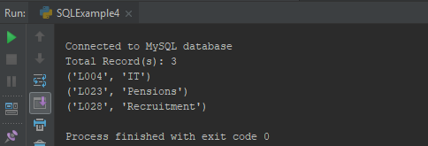

Refresh the phpMyAdmin interface, the Department table has a new record inserted.

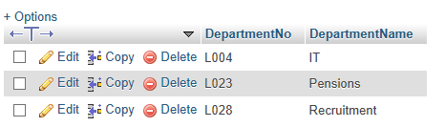

Exercise: Add your comments to the above Python program to ensure that you understand the code.

2.2.4 SQL Statement: Delete

This section introduces the SQL delete statements to delete records of a database table.

Example 5: The following Python script will delete a record of DepartmentNo, L028, in the Example database.

Create a Python file, named SQLExample5.py. Copy the code below and paste it into SQLExample5.py.

import mysql.connector
from mysql.connector import MySQLConnection, Error
def connect():
""" Connect to MySQL database """
try:
conn = mysql.connector.connect(host='localhost',
database='example',
user='root',
password='')
if conn.is_connected():
print('Connected to MySQL database')
except Error as e:
print(e)
return conn
def delete(conn, id):
query = "DELETE FROM department WHERE DepartmentNo = %s"
try:
cursor = conn.cursor()
cursor.execute(query, (id,))
conn.commit()
except Error as error:
print(error)
def view_all(conn):
try:
cursor = conn.cursor()
cursor.execute("SELECT * FROM department")
rows = cursor.fetchall()
print('Total Record(s):', cursor.rowcount)
for row in rows:
print(row)
except Error as e:
print(e)
finally:
cursor.close()
conn.close()
if __name__ == '__main__':
conn = connect()
delete(conn, 'L028')
view_all(conn)

Run the program, the results are shown below.

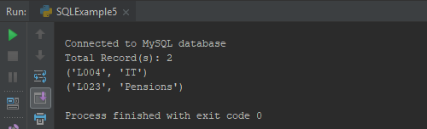

Refresh the phpMyAdmin interface, the Department table has a new record inserted.

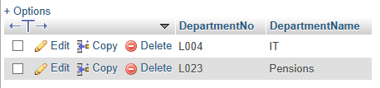

Exercise: Add your comments to the above Python program to ensure that you understand the code.

2.3 Activity

Exercise 1: to create a new table, called employee, with the following columns and data:
- EmployeeNo: varchar with length 6, primary key
- EmployeeName: varchar with length 30, not null
- DepartmentNo: varchar with length 4, foreign key

Enter the following record into the employee table.
Notes: to enter DepartmentNo in the employee table and set it to be a foreign key as below.
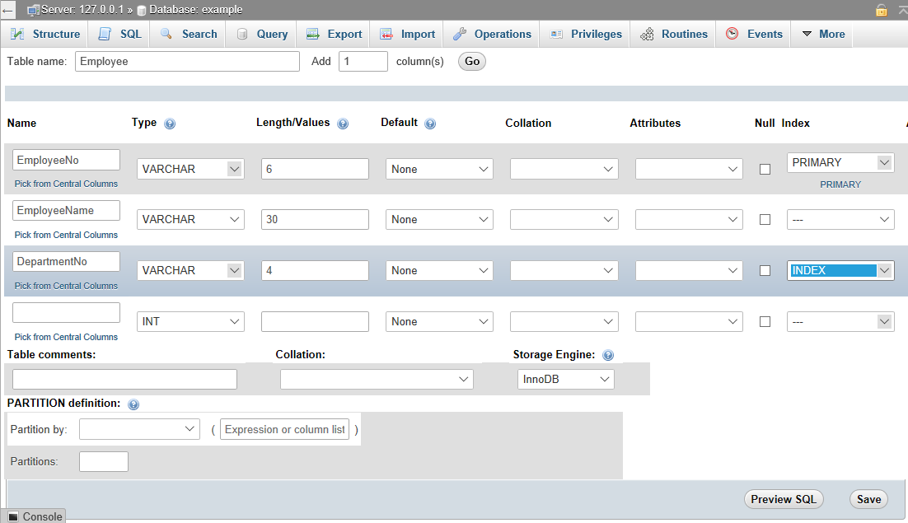
For the DepartmentNo column, click the drop down box and select INDEX.

The Add index box shows. Enter the details as shown here. Click Go.

Click Save

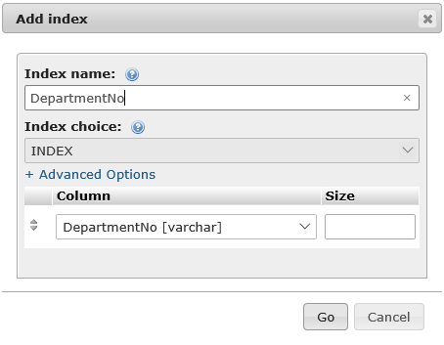

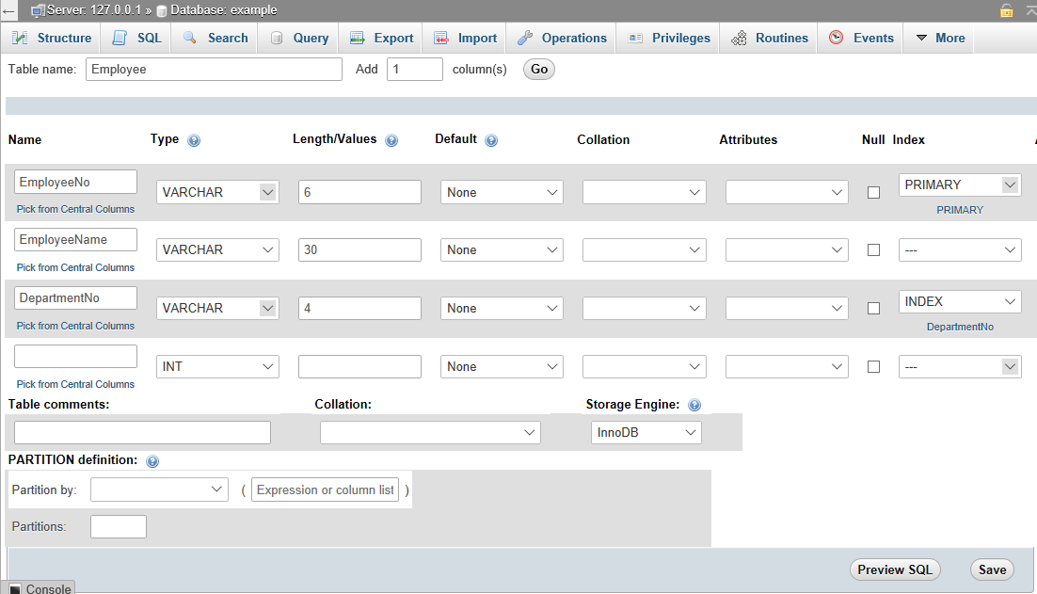
The DepartmentNo is shown here.

Exercise 2: Write a Python program to find out the name of department in which employee, A Smith, works.

